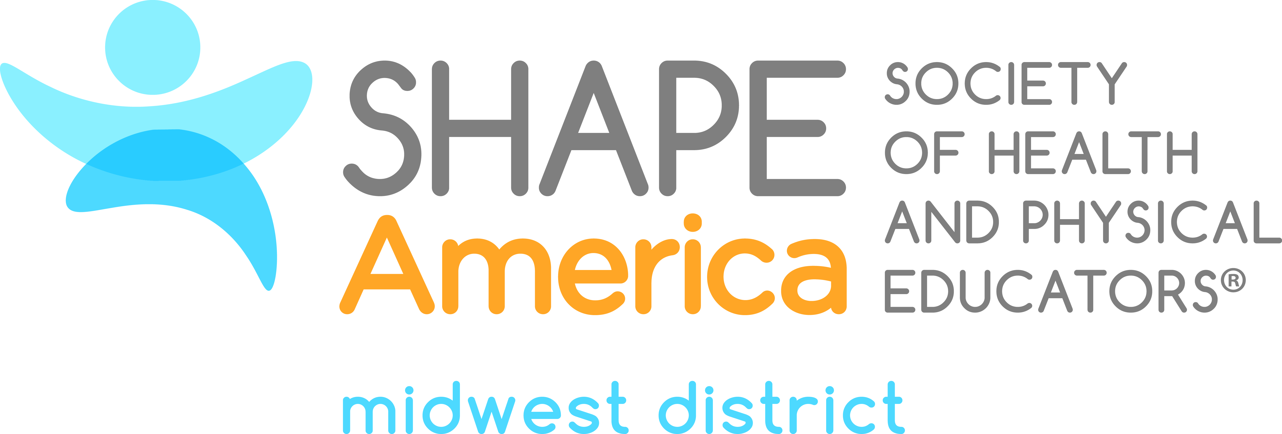

2019 Candidate for the Office of Member-at-Large

Scott Przystas
Elementary Physical Education Teacher
Grand Haven Public Schools
Grand Haven, MI

Scott Przystas has been teaching in Grand Haven Area Public Schools for 10 years. He has taught Young 5s-12th grade throughout the district in various buildings in various classes such as Physical Education, Adapted PE, Triathlon Training, and Weight Training. He also coaches high school cross country, junior varsity basketball and middle school track. Prior to coming to Grand Haven, he attended Michigan State University where he got his Bachelor’s of Science degree in Kinesiology with specializations in Coaching as well as Health Promotion. He also received his Master of Arts in Education from Michigan State with concentrations in P-12 Administration and Sport and Coaching Leadership. Scott is a member of the Michigan Governors Council of Fitness, Health and Sport. The mission of the Council is to inspire active lifestyles and healthy food choices in the places we live, work and play. Scott is also a member of the Michigan High School Athletic Association’s Multi-Sport Task Force. Through the task force, Scott has helped prepare strategies and tactics for the MHSAA, allied organizations and local schools to promote multi-sport participation by student athletes. Finally, Scott has been a board member for SHAPE Michigan for 4 years as a Regional Representative. He has co-directed 3 regional workshops in West Michigan. He has also presented at SHAPE Michigan and was recently accepted to present at SHAPE America in Tampa in 2019. Scott resides in Grand Haven with his wife, Renee and two sons, Calyx and Krew.

